Name:
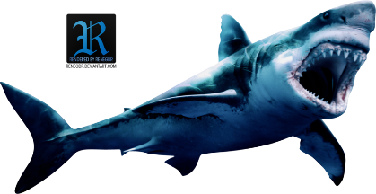Tank

- What is your Favorite Product or service? Why?

- Did that product or service get a deal? If so what did they receive? If not why do you think they didn’t?

- What was the worst product or service? How could you have made it better?

- What product or service would you bring to the Shark Tank?????

